



“Holistic Restoration of Degraded Forest Lands: Nature-Based and Climate-Adapted Solutions Across Drin River Basin”

Impacts and Lessons from Albania

January 2025
Connecting Natural Values & People Foundation

Project implementation: Financed by: managed by ICEP
and funded by ADA

Holistic Restoration of Degraded Forest Lands: Nature-Based and Climate-Adapted Solutions Across Drin River Basin.

Impacts and Lessons from Albania
Contents
1 Introduction 2
2 Background/context 3
3 Methodology/approach 5
4 Partners 9
5 Main results/findings 9
6 Lessons learned 11
7 Challenges and opportunities 13
7.1 Challenges: 13
7.2 Opportunities: 13
8 Conclusions and recommendations 14
8.1 Conclusion: 14
8.2 Recommendations: 15

List of figures
Figure 1 - Poject area in Ana e Malit 4
Figure 2 - The map of Ana e Malit area according to species planted 6
Figure 3 - The map of the area planted in Vau i Dejës 7
Figure 4 - Area in Vau i dejës presented in forestry map 7
Figure 5 - Planting scheme in Vau i Dejës 7
Figure 6 - Watering the pits in Vau i Dejës 8
Figure 7 - Buid stone check dams in Korthpulë 8
Figure 8 - Area in Korthpulë presented in forestry map 8

Acronyms
ADA Austrian Development Agency
CNVP Connecting Natural Values & People Foundation
GHGs Greenhouse gases
IFM Integrated Forest Management
ICEP Inspiring Cooperation Empowering People

Introduction

The "Integrated Forest Management along the Drin River Basin" project, implemented by CNVP and funded by the Austrian Development Agency (ADA) through ICEP (Inspiring Cooperation Empowering People), is an initiative aimed at restoring ecological balance and fostering sustainable land management in the Drin River Basin.
Albania has faced significant ecological challenges over the past few decades, with land degradation exacerbated by deforestation, overgrazing, wildfires, soil erosion, and unsustainable forestry practices. These factors, along with the effects of climate change such as droughts and extreme weather, have severely impacted local biodiversity and ecosystem functionality. Land degradation has also contributed to the release of carbon into the atmosphere, which further exacerbates climate change. The project uses nature-based solutions, to address these issues, restore ecological functions, and promote environmental sustainability. Three major projects have been implemented to tackle these challenges in key regions of the country: (i) the Korthpula project in the Puka district, (ii) the afforestation projects at Zalli i Gjadrit in the Vau i Dejes Municipality, and (iii) Bushat-Ana e Malit management unit in Shkodër municipality. While each initiative is tailored to the unique needs of its site, all share a focus on restoring degraded ecosystems, reducing soil erosion, and promoting sustainable practices that benefit both the environment and local populations.

The Korthpula project addresses erosion and sedimentation in one of Puka’s most vulnerable areas. This initiative combines biological, biotechnical, and engineering methods to mitigate soil loss, stabilize slopes, and protect water systems from sedimentation, particularly during heavy rainfall. Reforestation with chestnut trees (Castanea sativa Mill) of an area of 4.1 ha, is a cornerstone of the project, chosen for its ability to stabilize soil, enhance water retention, and provide long-term economic benefits through fruit production. Complementing these biological measures, the project incorporates brushwood and stone check dams to regulate water flow and prevent sediment displacement. Together, these strategies aim to restore ecological balance, enhance community welfare, and preserve biodiversity in the region, creating a more resilient landscape that benefits both nature and local livelihoods.
At Zalli i Gjadrit in Vau i Dejës Municipality, the focus shifts to combating hydrological erosion along a 2-hectare area by establishing a new forest stand. The project involves planting poplar, willow, considered as fast growing species, selected for their ability to stabilize soil, regulate water flow, and filter pollutants from entering the Gjadër River. In addition to environmental restoration, the project is deeply community-focused, providing local employment opportunities and fostering a sense of responsibility for environmental conservation among residents. The presence of these newly planted trees enhances biodiversity by creating habitats for local wildlife, while also contributing to climate change mitigation by increasing carbon sequestration. The next afforestation project focused on restoring an additional 7 hectares of land in the “Kodra e Magjypit” area. In addition to ecological restoration, the project was designed to provide economic opportunities for the local population, particularly the residents of the village of Oblike, in the Ana e Malit administrative unit, Shkodër Municipality. It aimed to create jobs, raise awareness about forest conservation, and involve the local community in sustainable forestry practices, which will ultimately help improve the quality of life in the region.
Collaboration among CNVP, local forestry staff, and community organizations has been pivotal in ensuring the project’s success and reinforcing the critical role of community engagement in sustainable land management.
The “Integrated Forest Management along the Drin River Basin” project builds on prior successes in afforestation and sustainable forestry, focusing on rehabilitating degraded land through reforestation with both forest and fruit tree species. Central to this effort is the restoration of chestnut groves, which historically played a key role in the local economy but have suffered significant declines due to disease and pests. High-quality chestnut seedlings have been introduced alongside wild pine, cypress, and fruit trees like olive and pomegranate to restore the land’s ecological function and economic value. By addressing soil erosion, enhancing water retention, and improving biodiversity, the project also provides critical economic opportunities for local residents, creating jobs and encouraging community involvement in sustainable forestry practices.
These projects, while addressing site-specific challenges, share the common goal of integrating ecological restoration with socio-economic development. They demonstrate the power of nature-based solutions, such as reforestation, to address pressing environmental issues while fostering economic growth and improving community well-being. By employing collaborative approaches and tailoring strategies to the unique conditions of each region, these initiatives stand as models for sustainable environmental management and a testament to the potential for restoration efforts to transform landscapes and livelihoods alike.

Background/context

Albania’s landscape, while rich in biodiversity and ecological significance, is highly vulnerable to land degradation and erosion due to a combination of natural factors and human activities. Among the most affected areas are Ana e Malit, Korthpulë and Zalli i Gjadrit within the Drin River Basin. Over the years, these areas have been subject to deforestation, unsustainable land use practices, and climatic extremes, leading to widespread ecological instability, reduced agricultural productivity, and socio-economic challenges for local communities. Addressing these issues requires a multidisciplinary approach combining afforestation, soil stabilization, and community engagement, which underpins the objectives of the three major projects targeting these regions.

The “Integrated Forest Management along the Drin River Basin” project, implemented by CNVP and ICEP, with long-standing expertise in the Western Balkans and funded by the Austrian Development Agency (ADA), focuses on combating forest degradation and promoting sustainable forestry practices in one of Europe’s most water-rich regions. This transboundary area, spanning Albania, Kosovo, North Macedonia, and Montenegro, is characterized by its rich biodiversity and extensive freshwater ecosystems. However, decades of illegal logging, overgrazing, wildfires, and climate-induced droughts have severely degraded forest ecosystems and destabilized landscapes.

Restoration using nature base solutions in Ana e Malit locality in Shkoder Municipality

The project targets areas such as the Bushat-Ana e Malit management unit and the Magjypi hills near Tarabosh Mountain, aiming to reverse land degradation through integrated forest management (IFM) practices. By engaging local communities and employing reforestation techniques, including planting Mediterranean-native species such as evergreen oak, Macedonian oak, and Aleppo pine, the project seeks to stabilize soils, improve water retention, and enhance biodiversity. Historical agricultural practices, such as the communist-era cultivation of fruit trees, are also revisited by incorporating olives and pomegranates into restoration plans.

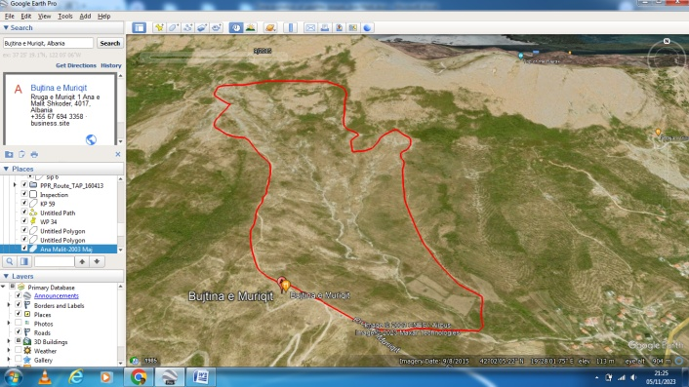
With a Mediterranean climate and clay-rich soils prone to erosion, the project emphasizes the ecological and socio-economic benefits of reforestation. Afforestation efforts across 7 hectares address pressing environmental challenges such as carbon sequestration and climate change mitigation while creating employment opportunities and fostering environmental awareness within local communities.
Figure 1 - Poject area in Ana e Malit

Fast-growing tree plantations as a solution to face climate change at Zalli i Gjadrit location in Vau i Dejës Municipality

The afforestation project at Zalli i Gjadrit in Vau i Dejës Municipality directly addresses the region’s heightened vulnerability to extreme rainfall events exacerbated by climate change. The Gjadri River, part of the Drin River system, plays a vital role in supporting agriculture and local hydrology. However, sedimentation, soil erosion, and altered water flows due to hydropower infrastructure have compromised its ecological function.

This project involves creating a forest stand over 2 hectares within the Drin-Gjadër-Kir management unit. By planting fast-growing species such as poplar, willow, and ash, the initiative reduces soil erosion, regulates water flow, and supports biodiversity restoration. The Mediterranean Fluvisol soil, with moderate organic carbon content, provides an adequate foundation for establishing forest cover, despite low nitrogen and humus levels.

The project extends beyond ecological restoration to socio-economic development. Located near accessible infrastructure and local villages, it offers employment opportunities while raising awareness about sustainable forestry. By addressing land degradation, enhancing ecosystem functionality, and creating habitats for local wildlife, the Zalli i Gjadrit project serves as a model for nature-based solutions to climate impacts.

Erosion Mitigation in the Korthpula Zone in Puka Municipality

The Korthpula zone in Puka Municipality exemplifies the challenges of land degradation in mountainous catchment basins. With steep slopes, heavy annual rainfall exceeding 2,100 mm, and a history of deforestation and overgrazing, the area faces severe soil erosion and sedimentation issues. These factors have disrupted irrigation channels, destabilized hillsides, and intensified sedimentation in water systems, jeopardizing both environmental health and community resilience.

The project in Korthpula integrates biological, biotechnical, and engineering interventions to stabilize the basin and mitigate erosion. Measures include reforestation with chestnut and other native species, check dams, and streambed reinforcement to manage sediment flows and protect critical infrastructure, such as national roads and irrigation systems.

The project area, characterized by brown mountain soils with varying acidity and fertility, benefits from targeted restoration strategies that enhance soil stability and productivity. By involving local communities in sustainable resource management, the initiative promotes long-term ecological recovery and socio-economic improvement.

All these project sites collectively address Albania’s pressing environmental challenges by leveraging nature-based solutions and fostering community participation. While tailored to the unique ecological and socio-economic contexts of their respective sites, all three initiatives share a commitment to restoring degraded landscapes, mitigating climate change impacts, and improving the livelihoods of rural populations.

Methodology/approach

The methodology employed in these afforestation and sustainable land management projects was complex, combining biological, biotechnical, and engineering techniques to ensure effective, sustainable, and long-term outcomes. A strong emphasis was placed on tailoring interventions to the unique environmental and socio-economic conditions of each region while promoting community involvement and ecological restoration. A cornerstone of the projects was the integration of modern afforestation techniques, forest rehabilitation, and the generation of income opportunities for local communities. Efforts were also directed towards fostering regional expertise in Integrated Forest Management (IFM), enabling knowledge exchange and collaboration. Academic research and consultancy support were key components in assessing project activities, enhancing methodologies, and advocating for the adoption of IFM practices across the region. A consultant specializing in afforestation was engaged to provide technical guidance and develop case studies that documented the implementation process and outcomes.

The selection of tree and shrub species was guided by comparative ecological analysis, ensuring compatibility with local environmental conditions and climate resilience. For instance, the project implemented in Ana e Malit was focused on reforestation with ecologically and economically significant species such as Holm oak (Quercus ilex), Black alder (Alnus glutinosa), Aleppo pine (Pinus halepensis), and Wild olive (Olea europaea). In total were planted 12131 seedlings covering 7 ha of degraded land.

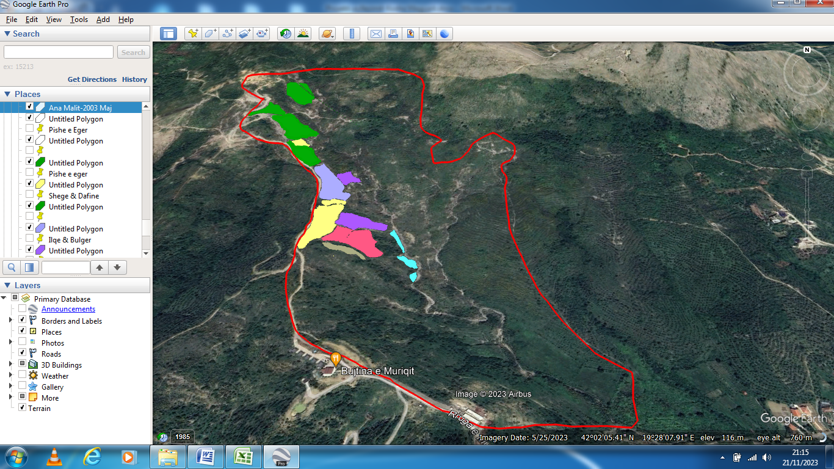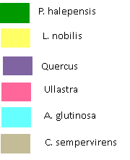
Figure 2 - The map of Ana e Malit area according to species planted
In the Bushat-Ana e Malit management unit, the planting formula was tailored to local conditions, with a proportional mix of species designed to maximize both ecological and economic benefits. For example, Aleppo pine and Holm oak comprised 42% of the total planting mix due to their adaptability and economic potential. Local communities played an active role in reforestation efforts, contributing their knowledge and benefiting from income-generating opportunities tied to the project.

Nr | Specia | Sipërfaqja (m²) | Numri i fidanëve
1 | Ilqe (Q. ilex) | 6656 | 2600
2 | Bulgeri (Q. trojana) | 2560 | 1000
3 | Vidh fletngushtë (A. glutinosa) | 10000 | 1333
4 | Dafina (L. nobilis) | 10000 | 1333
5 | Ullastra | 10000 | 1333
6 | Pishë e egër (P. halepensis) | 22784 | 2532
7 | Selvi (C. sempervirens) | 8000 | 2000
 | TOTALI | 70000 | 12131

Similarly, the Zalli i Gjadrit project utilized White Poplar (Populus alba) and White Willow (Salix alba) to stabilize soil and mitigate erosion. In total were planted 1556 poplar and 667 willow seedlings in a 2 ha area along the Gjadër river. In contrast to Ana e Malit, the project in this site employed a fixed ratio of 70% White Poplar to 30% White Willow. The planting was executed using a 3 m x 3 m planting distance, ensuring uniform spacing and facilitating maintenance.

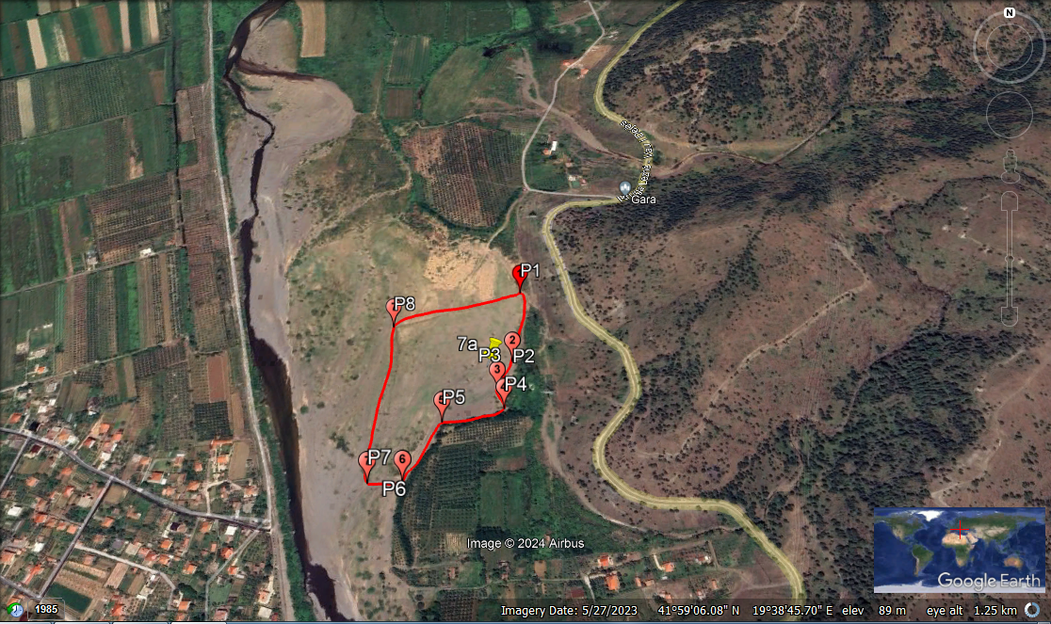
Figure 3 - The map of the area planted in Vau i Dejës

The methodologies applied in both locations adhered to strict guidelines for species suitability, emphasizing biodiversity, adaptability to climate change, and community benefits. Planting schemes varied based on site-specific requirements, with some areas adopting irregular patterns due to existing vegetation, while others utilized systematic grids for optimized spacing. Planting pits were prepared with dimensions tailored to the species’ needs, ensuring proper root development. Soil preparation involved removing weeds, loosening compacted soil, and organizing soil layers to optimize root growth and nutrient availability. Organic fertilizers or humus were applied at rates determined by the species and site conditions to promote initial growth. After planting, pits were watered to eliminate air pockets and ensure even soil saturation.

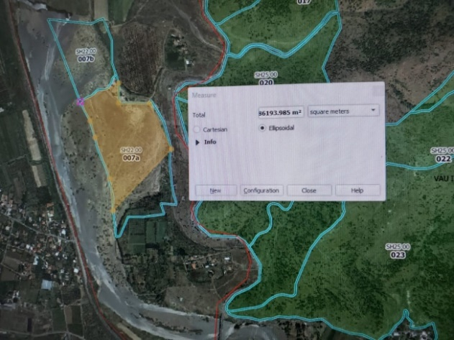  Figure 4 - Area in Vau i dejës presented in forestry map | 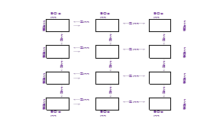  Figure 5 - Planting scheme in Vau i Dejës

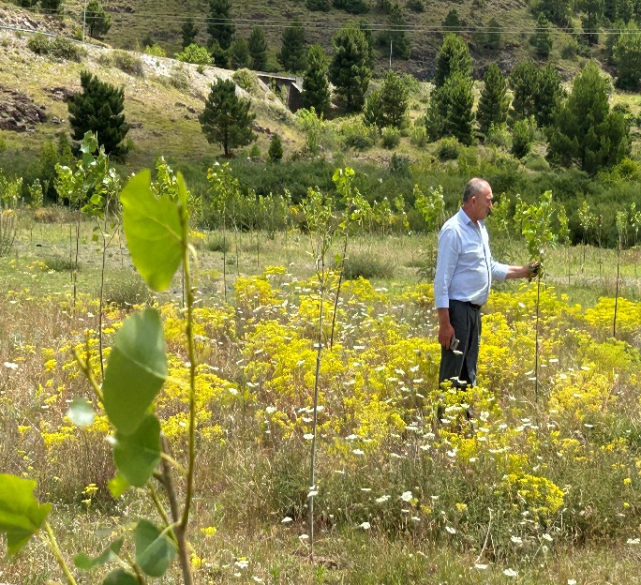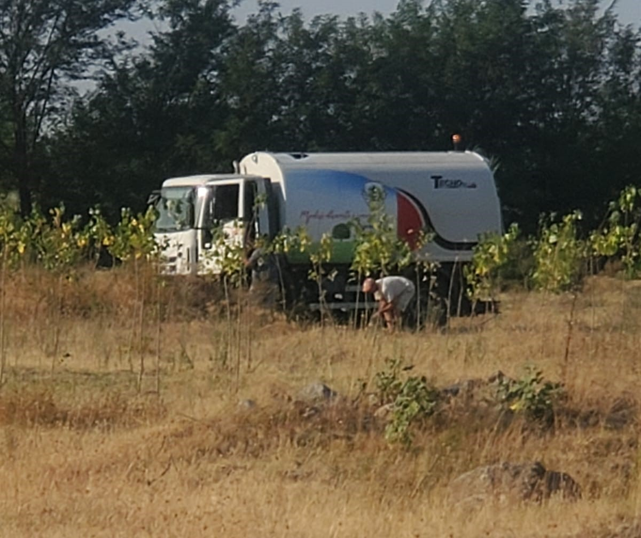
Figure 6 - Watering the pits in Vau i Dejës
The Korthpula project implemented a sophisticated methodology to address erosion and ecosystem degradation, integrating biological, biotechnical, and engineering measures. Native species, such as chestnut (Castanea sativa), was planted in a 4.1 ha area to stabilize soils and enhance biodiversity. In total were planted 1140 seedlings in a distance 6 x 6 m. Biotechnical solutions included constructing single and double brushwood check dams to form sediment traps and applying organic mulch to protect topsoil.in total were placed 50 vegetative traps across the project area. Engineering interventions involved building stone retention walls to stabilize slopes, along with installing check dams in gullies to prevent sediment displacement. In total were constructed 8 stone check dams along the gully eroded channels to prevent soil erosion by reducing flow velocity.
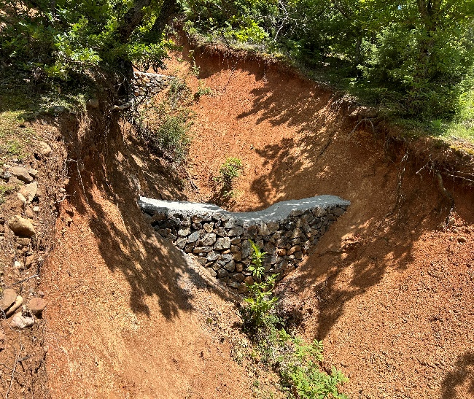  Figure 7 - Buid stone check dams in Korthpulë | 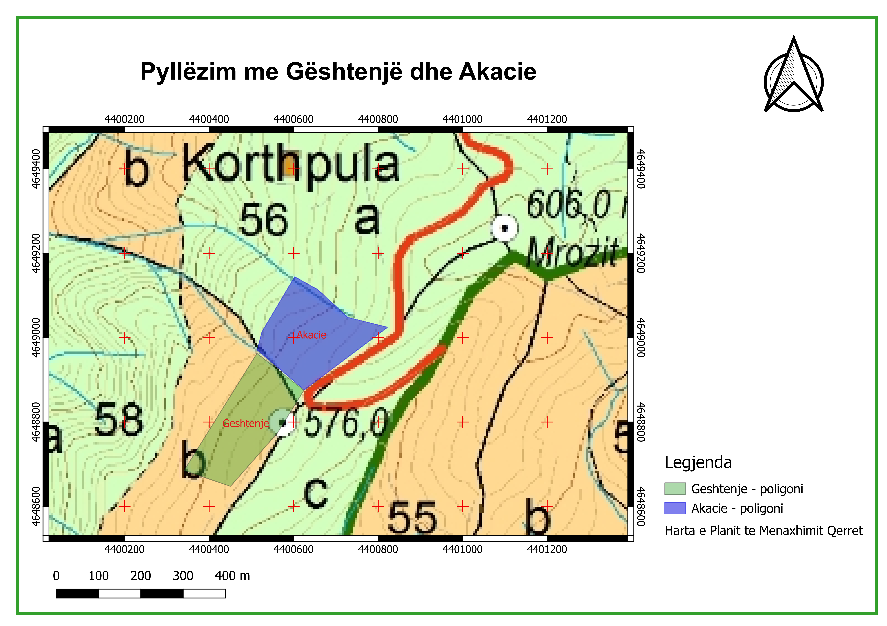  Figure 8 - Area in Korthpulë presented in forestry map

The planting process across all projects was meticulous, incorporating preparatory steps such as land clearing, marking planting positions, and digging planting holes weeks in advance to allow soil settlement. Seedlings were sourced from certified nurseries to ensure quality and ecological suitability. Protection measures, such as fencing and pest management, were implemented to safeguard young plants from grazing and disease. Monitoring protocols included assessing survival rates during designated periods and replacing any non-viable seedlings in subsequent planting seasons.

Aftercare measures were provided during the first two years to maximize survival rates and promote robust growth. These included weeding, watering, and fertilizing based on site-specific needs. Watering was conducted during late afternoons to optimize moisture absorption, and water sources, such as the Buna River, were utilized. Collaboration with local stakeholders, including municipalities and community groups, was integral to the projects’ success, ensuring long-term maintenance and management of the afforestation sites. By fostering regional expertise, promoting community involvement, and employing scientifically sound practices, these projects not only restored degraded ecosystems but also provided socio-economic benefits and strengthened climate resilience.

Partners
The success of the three projects is attributed to a collaborative network of stakeholders:
- ADA (Austrian Development Agency)
- ICEP (Inspiring Cooperation Empowering People)
- CNVP Foundation
- National Forest Agency
- Forestry Technical High School “Kolë Margjini”, Shkodër
- Municipalities of Shkodër, Vau i Dejës and Puka
- Municipality Forest Staff
- Shkodër Communal Forest & Pasture Federation
- Local Communities
- Community Representatives

Main results/findings

The implemented projects in the Drin River Basin have produced significant ecological, environmental, and socio-economic outcomes. These projects have played a vital role in restoring degraded landscapes, enhancing biodiversity, and supporting local communities. The key findings and results from these projects are outlined as follows:
1. Vegetation and Habitat Restoration: One of the most prominent achievements across all the projects has been the substantial increase in vegetation coverage. In the Drin River Basin, the afforestation efforts led to the successful planting of a variety of tree species, such as Chestnut, Aleppo pine, Holm oak, Cyprus cedar, Poplar, Willow among others. These efforts have restored important habitats for wildlife, providing new shelter and food sources for local fauna. The expanded vegetation coverage has created more complex forest structures, which in turn support a greater diversity of species. Local communities have reported an increase in wildlife presence, reflecting the positive effects of habitat restoration on biodiversity. The newly created forests in these areas have not only rejuvenated the landscape but have also contributed to the overall ecological health of the region.
2. Soil and Water Management: The restoration projects of degraded lands also contributed significantly to improve soil health and water management. In the Drin River Basin, the newly established forest stands have enhanced soil stabilization, reducing the risks of landslides and mitigating the impact of extreme weather events such as droughts. The afforestation project has helped prevent soil erosion by anchoring the soil with tree roots, improving its structure and enhancing water retention capacity. In the Zalli i Gjadrit area, the project improved the water quality of local waterways by reducing sedimentation and regulating the water regime. These improvements in water management not only benefit the local environment but also help increase the resilience of these landscapes to climate change impacts, such as flooding and droughts.
3. Erosion Control and Climate Change Mitigation: Erosion control has been a central goal of these afforestation projects. In areas reinforced with vegetation and engineering structures, there has been a notable reduction in soil displacement. In the Drin River Basin, the newly planted forests have played a critical role in reducing soil erosion, particularly in vulnerable areas. This reduction in erosion, combined with improved water retention, helps stabilize the landscape and prevents further degradation. Additionally, the afforestation projects contribute to climate change mitigation by enhancing the region’s carbon sequestration capacity. The trees planted in these areas absorb carbon dioxide from the atmosphere, helping to reduce greenhouse gas emissions. As the trees continue to mature, the carbon sequestration potential of the forests is expected to increase, making a significant contribution to the fight against climate change.
4. Socio-Economic and Community Benefits: Beyond their environmental impacts, the afforestation projects have provided several socio-economic benefits to local communities. The creation of new forest stands, such as those in Kodra e Magjypit and Zalli i Gjadrit, has provided valuable resources, including wood material, for local residents. These forests also offer economic opportunities through the production of timber and other forest products. Additionally, the projects have contributed to the local economy by creating a source of sustainable income through the long-term carbon sequestration and ecosystem services offered by the newly planted forests. Moreover, the afforestation initiatives have helped raise awareness among local communities about the importance of sustainable land management practices. These efforts have empowered residents to take an active role in the preservation and restoration of their environment, ensuring that the benefits of these projects are felt for generations to come.
5. Economic Viability and Cost-Benefit Analysis: A thorough cost-benefit analysis was conducted for the Zalli i Gjadrit afforestation project to evaluate its economic feasibility. The project required an initial investment of 10,583 Euros, and it is expected to generate 211,503 Euros in revenue over the 40-year production cycle of the Poplar trees. This equates to an annual revenue of 5,288 Euros. Based on these figures, the project is expected to recover its initial investment within approximately 2.0 years, with a net economic benefit of 200,920.27 Euros over the full 40-year period. These results demonstrate that the afforestation projects not only offer substantial environmental benefits but also provide a positive return on investment. The economic viability of the projects supports their long-term sustainability and reinforces their potential as a model for future afforestation efforts.
6. Overall Ecological Improvement: Collectively, the afforestation projects in the Drin River Basin have led to a substantial improvement in the ecological environment. The combination of increased vegetation coverage, enhanced soil health, improved water management, and carbon sequestration has revitalized the local ecosystems. These improvements are expected to continue as the forests mature, further increasing their ecological value and the resilience of the region to climate change. The afforestation projects have demonstrated that large-scale land restoration efforts can have transformative impacts on both the environment and the communities that depend on these ecosystems.

In conclusion, the afforestation projects have successfully addressed several critical environmental challenges, including soil erosion, water management, habitat restoration, and climate change mitigation. They have also provided significant socio-economic benefits to local communities by creating economic opportunities, raising awareness about sustainable land management, and supporting wildlife conservation. These projects highlight the potential of afforestation as a tool for promoting ecological balance, mitigating the impacts of climate change, and fostering sustainable development in vulnerable landscapes. As these forests continue to grow, their ecological and economic contributions will further strengthen the long-term resilience of the region.

Lessons learned

The afforestation projects implemented in the Drin River Basin have provided valuable lessons that will inform future environmental restoration efforts. These insights are crucial for improving the sustainability and success of similar initiatives. The following key lessons have emerged from the planning and implementation of these projects:
- Species Selection and Site Suitability: A critical lesson learned from these projects is the importance of selecting species that are well-suited to the local environmental conditions. For instance, in the Ana e Malit, species such as Aleppo pine, Holm oak, and Cyprus cedar were chosen for their adaptability to the site’s specific needs. Similarly, in Zalli i Gjadrit, Populus alba (White Poplar) and Salix alba (White Willow) were selected due to their compatibility with the climate and soil conditions. This careful selection of species plays a crucial role in ensuring the long-term success of the afforestation, particularly in the face of changing climate conditions.
- Flexibility and Adaptability in Planting: The implementation of these projects highlighted the need for flexible planting strategies that can accommodate local vegetation and site conditions. In the Ana e Malit, the presence of older vegetation required an irregular planting scheme to integrate the new seedlings with the pre-existing flora. Additionally, the tailored planting strategy in this site, which included the use of species like Common elm along watercourses and Italian cypress to prevent wildfires, demonstrated the importance of adapting the approach to specific ecological needs. This flexibility in planting schemes allows for more effective ecosystem restoration and ensures the success of the afforestation project.
- Holistic and Integrated Approaches: The effectiveness of combining multiple methods biological, engineering, and biotechnical has been another key lesson. The integration of these approaches, particularly in areas with degraded ecosystems, has proven to be more effective than relying on a single method. For example, the combination of vegetation planting and the use of engineered structures for erosion control in the Korthpulë site significantly improved the resilience of the landscape. This integrated approach also contributes to the long-term sustainability of the afforestation efforts.
- Soil Preparation and Planting Hole Design: Proper soil and planting hole preparation were found to be critical for the effectivity of afforestation. Ensuring that planting holes were adequately prepared and that soil conditions were optimal for root development significantly increased seedling survival rates. This insight emphasizes the importance of preparing the planting site well in advance of the planting season, ensuring that the conditions are right for the successful growth of the trees.
- Ongoing Monitoring and Maintenance: Regular monitoring and maintenance during the early stages of the restoration projects are essential for ensuring the long-term survival and growth of the planted trees. In both sites (e.g. Ana e Malit and Zalli i Gjadrit), the projects highlighted the importance of post-planting activities such as monitoring seedling survival, controlling weeds, and providing necessary irrigation and fertilization during the first two years. Proactive management during these early stages is crucial for securing the investment made in these projects and ensuring that they deliver positive environmental outcomes.
- Community Involvement and Empowerment: The involvement of local communities in the afforestation efforts was a major takeaway from these projects. Engaging local workers from nearby villages not only contributed to the operational success of the projects but also provided significant economic benefits to the communities. This community-centric approach fosters a sense of ownership and responsibility among local populations, ensuring that the benefits of the afforestation projects are sustained over time. Furthermore, it highlights the importance of local involvement in the planning, implementation, and maintenance phases of environmental restoration projects.
- Risk Management and Adaptability: Throughout the implementation of the afforestation projects, the need for effective risk management strategies became evident. Unforeseen challenges such as extreme weather conditions, grazing by livestock, and the potential for wildfires were encountered. In response, protective measures, including fencing and careful monitoring of environmental factors, were put in place. These proactive steps helped mitigate risks and ensured that the projects stayed on track. Additionally, the ability to adapt to changing conditions and address unforeseen challenges is crucial for the success of long-term environmental restoration efforts.
- Minimizing Negative Environmental Impacts: Efforts to minimize the negative environmental impacts of the projects were also an important lesson learned. In particular, the decision to avoid using chemical fertilizers helped preserve the quality of surrounding soil and water. While some challenges, such as emissions from transportation and noise disturbances, were unavoidable, the focus on sustainable practices reinforced the importance of minimizing environmental damages during both the implementation and post-planting phases.

Challenges and opportunities

Challenges:
- Chestnut Tree Drying and Pest Damage: The existing chestnut forest stands are facing issues related to drying out and being damaged due to tree cancer and fly infestations. This highlighted the need for effective pest management and the selection of more resilient species to avoid such problems in future projects.
- Quality of Afforestation Practices: One of the greatest risks was the quality of the work, particularly in digging planting holes and planting seedlings. Poor land preparation could lead to insufficient root development, reducing the chances of seedling survival and long-term success.
- Soil Compaction and Seedling Planting: Soil compaction and improper planting techniques hindered root development. The team had to ensure proper soil preparation and planting methods to avoid issues such as poor growth and water drainage, which could negatively impact seedlings.
- Extreme Weather Conditions: Unpredictable weather conditions, including frosts and heatwaves, posed significant risks to newly planted seedlings. The team needed to monitor weather patterns and adapt management practices to protect the seedlings from extreme temperatures.
- Livestock Grazing: Grazing by livestock, particularly goats and sheep, threatened the planted seedlings. Livestock could damage or trample the young trees, requiring the implementation of protective measures like fencing or guards to safeguard the seedlings.
- Intentional Damage and Fires: Deliberate damage to the afforestation site or forest fires posed significant risks. Fires, in particular, could destroy large sections of newly planted trees and damage the ecosystem, necessitating preventative measures like fire breaks and fire management strategies.

Opportunities:
- Local Employment Creation: The afforestation project provided local employment opportunities, particularly in all locations. This not only helped improve the community’s economic conditions, but also fostered local involvement in the restoration process.
- Community Engagement and Awareness: The project encouraged community participation, raising awareness about forest conservation and sustainable practices. It helped local residents better understand the benefits of afforestation and fostered a sense of environmental stewardship.
- Environmental Benefits: Despite the challenges, the project contributed to enhanced biodiversity, soil stabilization, and carbon sequestration. The new forest also provided habitat for local fauna, improving the overall ecological health of the region.
- Long-Term Ecological and Economic Gains: The afforestation project could provide long-term benefits, such as the sustainable harvesting of timber, medicinal plants, and non-timber forest products. It would also improve ecological services, including water regulation and soil protection, benefiting both the environment and the community.
- Water Regulation: The newly planted forest helped regulate water flow in the Gjadër River, reducing soil erosion, sedimentation, and improving groundwater recharge. It also acted as a natural filter for pollutants, enhancing water quality and supporting the local freshwater ecosystem.
- Capacity Building: Local communities were trained in forest management practices, equipping them with valuable skills that could be applied to similar future projects. This capacity-building effort empowered the community to engage in sustainable environmental practices.
- Policy Influence: The project served as a model for influencing national policies on using nature based solutions against soil erosion and sustainable land management. Its success has the potential to encourage the adoption of similar practices across the country.
- Replication Potential: The methodologies and outcomes from the project can be replicated in other regions, offering a blueprint for scaling up afforestation efforts and contributing to larger-scale environmental restoration projects.

Conclusions and recommendations

Conclusion:

In conclusion, the afforestation projects at Ana e Malit, Korthpulë, and Gjadër River, have made significant steps in addressing ecological challenges and combating land degradation in their respective regions. While these initiatives faced various obstacles, including pest infestations, extreme weather conditions, and difficulties with seedling establishment, the overall outcomes have been overwhelmingly positive. The projects have succeeded in increasing vegetation cover, restoring habitats, and improving ecological services, such as soil stabilization and enhanced carbon sequestration, across these sites. The newly established mixed forests in each location have not only contributed to mitigating climate change but have also enhanced biodiversity and provided new habitats for local wildlife.

Community involvement has been a critical factor in the success of all three projects. The engagement of local communities has created employment opportunities and raised environmental awareness, ensuring the sustainability of the projects. These afforestation initiatives at Ana e Malit, Korthpulë, and Gjadër River, now serve as models for future restoration efforts, demonstrating the effectiveness of nature-based solutions in addressing land degradation and promoting sustainable forest management practices.

As the forests mature, the long-term benefits of these projects are expected to grow, including enhanced biodiversity, improved soil health, and greater climate resilience. Furthermore, the creation of sustainable economic opportunities related to forest resources is poised to improve the livelihoods of local communities across the three regions.

Recommendations:
- Ongoing Monitoring and Maintenance: To ensure the continued success of the afforestation projects at Ana e Malit, Korthpulë, and Gjadër River, regular monitoring and maintenance activities are essential. These should include periodic weed control, watering, pest management, and fertilizing. These efforts will improve seedling survival rates and promote the long-term health of the newly planted forests.
- Adaptation to Climate Conditions: Future afforestation projects should take into consideration the potential impacts of extreme weather events such as heatwaves, frosts, and droughts. Selecting more resilient tree species suited to each region’s specific climate conditions and employing adaptive management practices will help mitigate risks related to climate change and improve the success of future initiatives.
- Strengthening Community Engagement: Continued involvement of the local communities in all three regions is vital for the sustainability of the afforestation projects. Offering ongoing training and awareness programs will further empower local residents to take an active role in forest management. This will help foster a strong sense of stewardship and ensure the projects’ long-term success in Ana e Malit, Korthpulë, and Gjadër River.
- Expansion of the Project Area: As the afforestation areas in Ana e Malit, Korthpulë, and Gjadër River mature, expanding the projects to additional degraded lands could provide significant ecological and socio-economic benefits. This expansion would further improve biodiversity, enhance ecosystem services, and create new job opportunities for local communities, further strengthening the region’s resilience to environmental challenges.
- Protection Against External Threats: All three sites should implement additional protective measures to guard against external threats, such as livestock grazing, wildfires, and human activities. This may include the installation of fences, creation of fire breaks, and monitoring of wildlife threats, ensuring that the newly planted seedlings are protected and able to thrive.
- Enhanced Funding: Securing additional financial resources for the afforestation projects at three locations is essential for their continued success. These resources will help expand the scope of these initiatives, improve infrastructure, and support sustainable forest management efforts, enabling the projects to have a lasting impact on the region’s ecological and socio-economic landscape.
- Policy Development: Advocating for stronger regulatory frameworks that support sustainable land management and forest conservation should be prioritized. By influencing national and regional policies, the success of the afforestation projects can be integrated into broader environmental and land management strategies, making these practices more widespread across other regions facing similar challenges.
- Knowledge Sharing and Replication: The findings and methodologies from the afforestation projects at Ana e Malit, Korthpulë, and Gjadër River, should be shared with other regions, encouraging replication of successful practices. By disseminating knowledge, these projects can serve as models for other communities and countries dealing with similar challenges related to land degradation and environmental restoration.
- Continuous Engagement: Maintaining strong partnerships with local communities, government agencies, and environmental organizations across all three regions will help ensure the long-term success of the projects. By continuing to collaborate, the projects can adapt to new challenges, refine forest management practices, and promote ongoing environmental education.

By addressing these recommendations and continuing to implement effective management strategies, these projects can further enhance their ecological and socio-economic impacts, being a significant step toward improving the environmental sustainability and economic well-being of the regions.

CNVP operates in the Balkan region. It focuses on natural resource management, forestry, agri-rural development and renewable energy, as well as the impact of climate change on the environment.

As a civil society organization, CNVP acts as a facilitator to:

- Strengthen community capacity to achieve local development goals;
- Maximize the production and service potential of rural areas through sustainable and locally controlled natural resource management;
- Promote the use of natural resources to improve socio-economic development and rural livelihoods; and
- Conserve the bio-diversity of natural resources at a time of serious environmental and climate change.

Core Values

- Green – intervening to build a greener economic environment within the ongoing process of climate change
- Clean – promoting renewable energy and improved household/industrial waste management
- Seen – operating in the Balkans and the European Neighborhood Space
- Lean – improving the efficiency of service delivery continuously and systematically
- Committed – working to achieve sustainable agri-rural and forestry development
- Innovative – incorporating new ideas into decision-making processes
- Team – sharing responsibility to achieve targeted results

Project managed by   | Co-financed by:   | Implemented in partnership with:  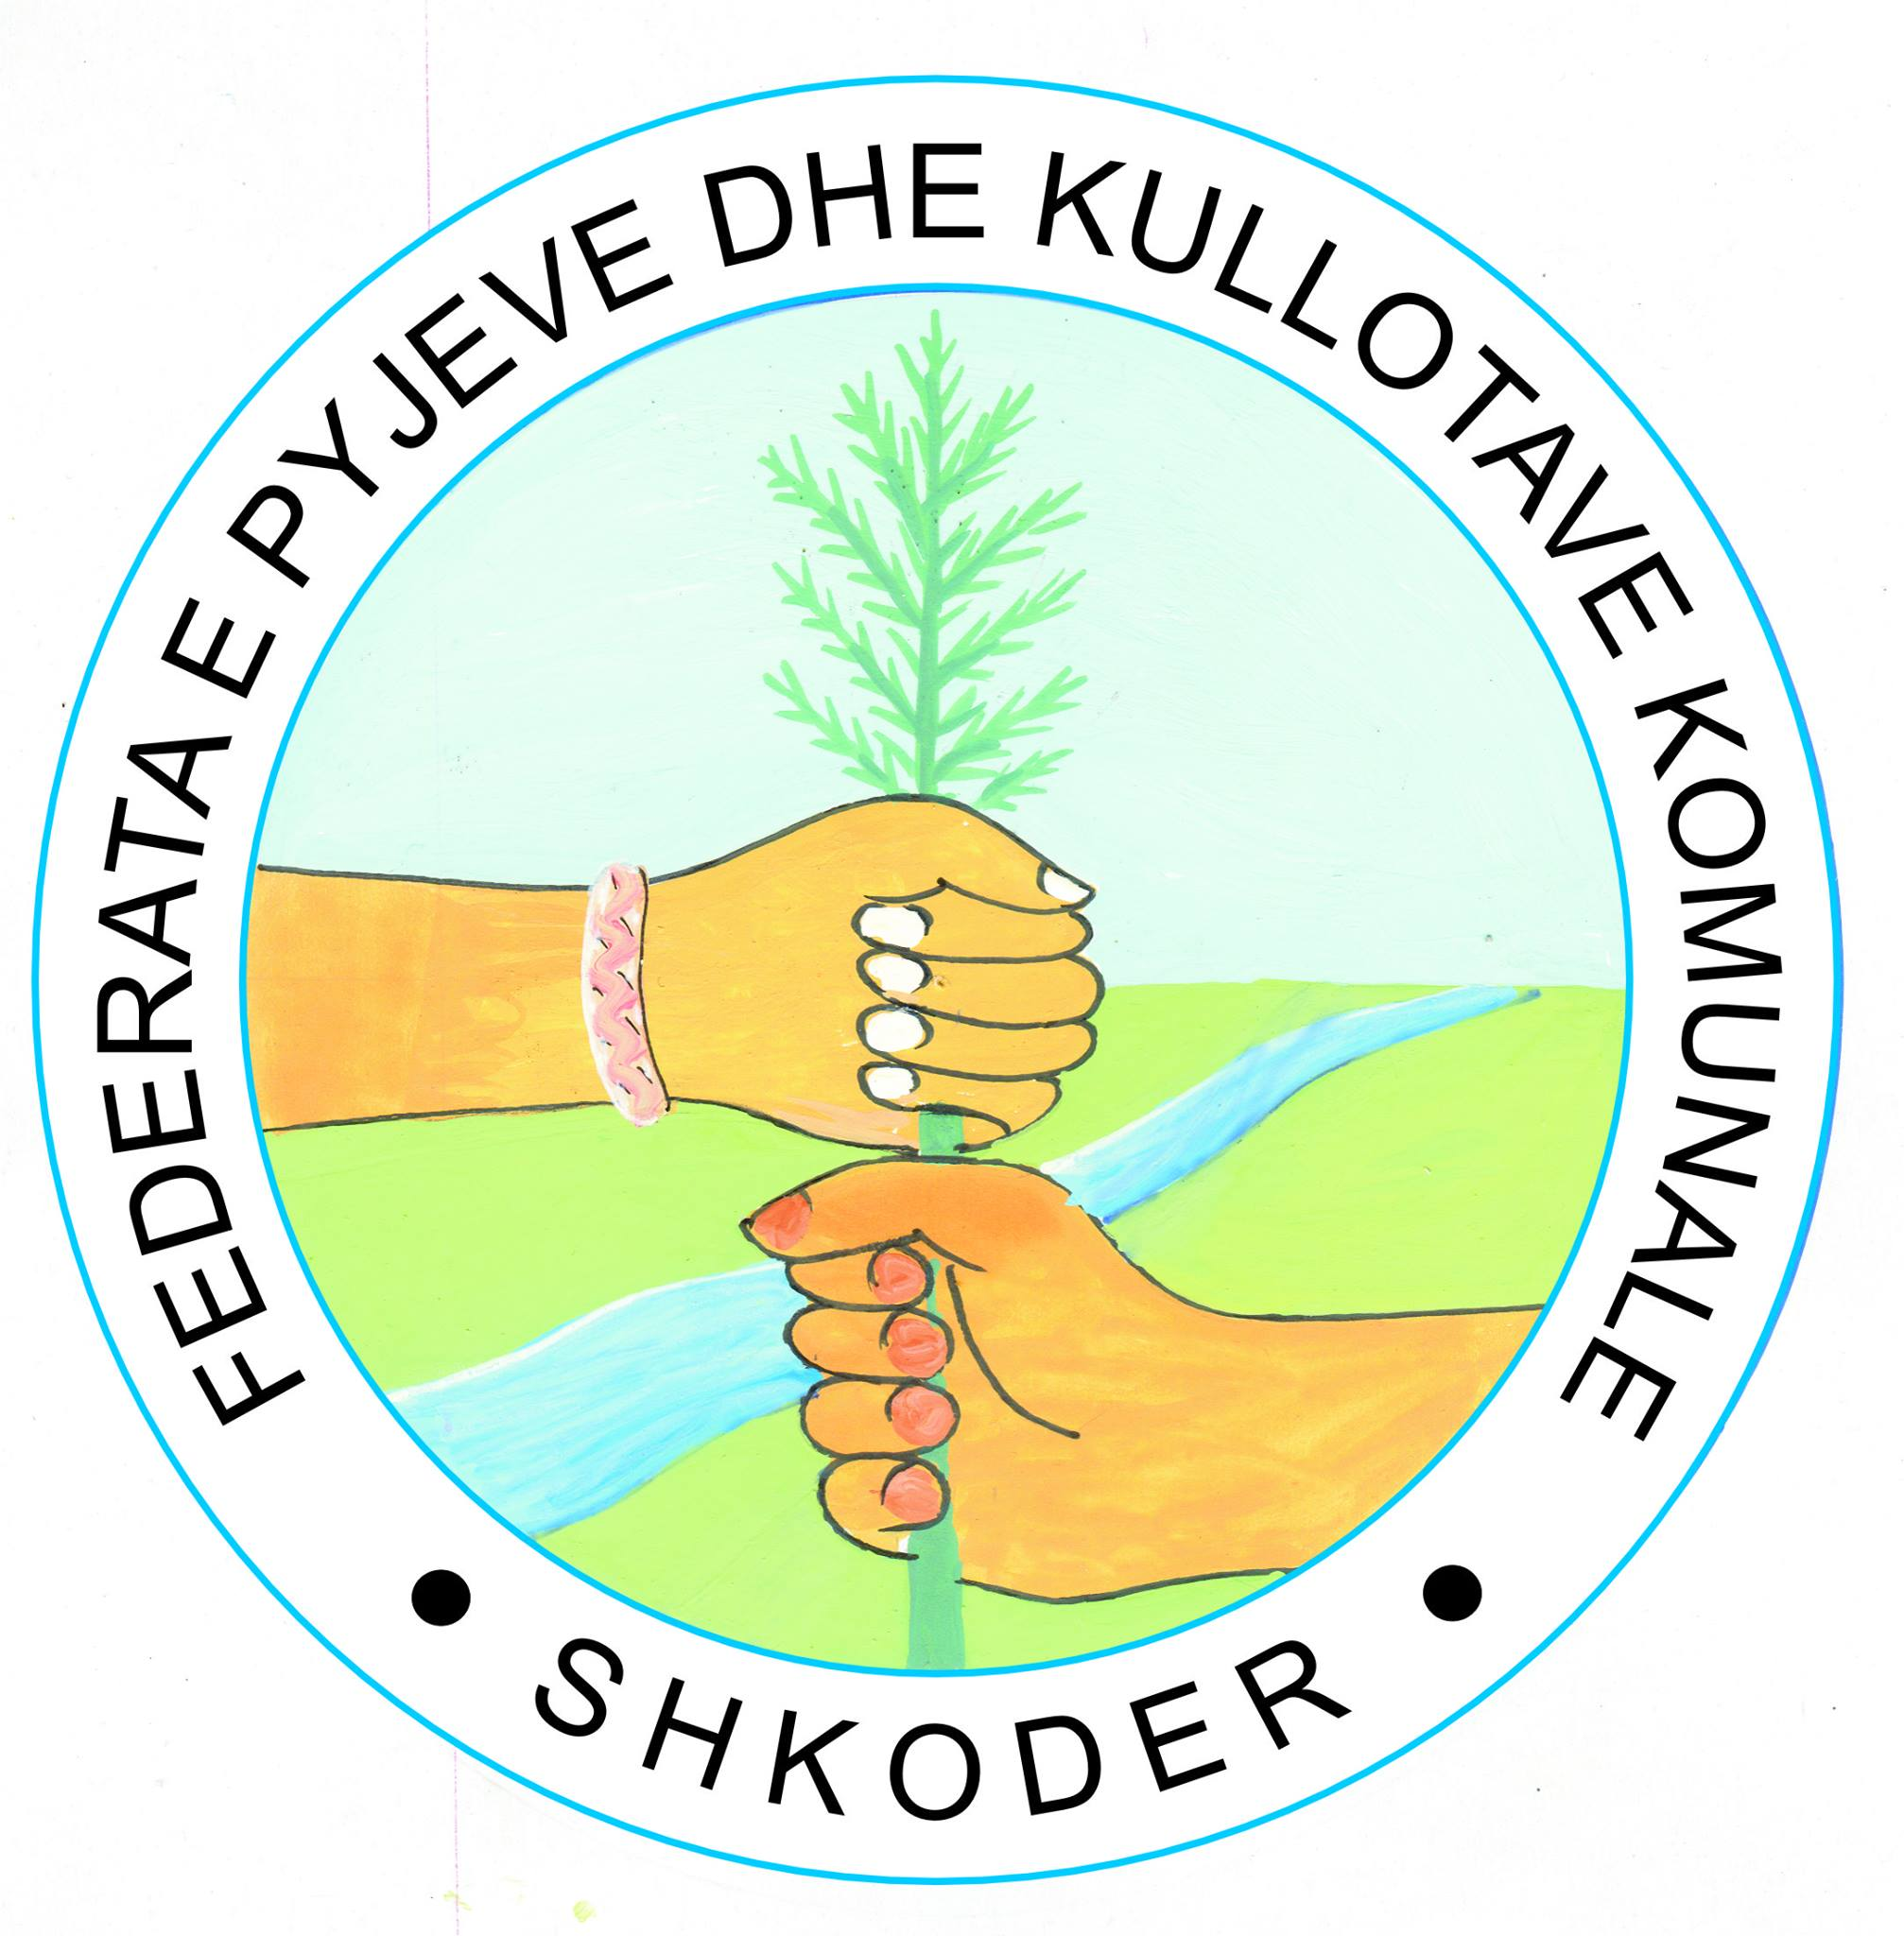
Connecting Natural Values & People
Zayed Centre Floor 7, Tirana e Re
PO Box 1735
Tirana, Albania,
Tel +355 4 222 9642, +355 4 2229551
www.cnvp-eu.org

